**Drill Rules**

1. Hole diameters

Holes with small diameters (less than 3.0 mm) or high depth-to-diameter ratios (greater than 2.75) are difficult to machine and are not recommended for convenient mass production. Deeper holes also make chip removal more difficult if the hole is blind.

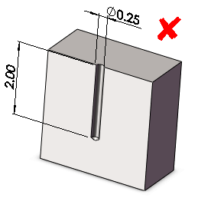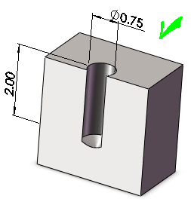

1. Hole with flat bottoms

Blind holes should be cone-bottomed rather than flat-bottomed. Flat-bottomed holes cause problems with operations such as reaming. Use standard twist drills to create cone-bottomed holes. The bottom angle should conform to the angle on standard drills.

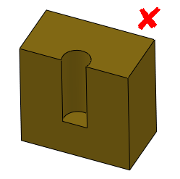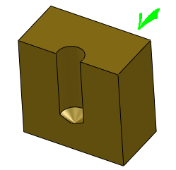

1. Hole entry and exit surfaces

The entry and exit surfaces of a drilled hole should be perpendicular to the hole axis. The drill tip can wander if the surface that the tip contacts is not perpendicular to the drill axis. Exit burrs will be uneven around the circumference of the exit hole, which can make burr removal difficult.

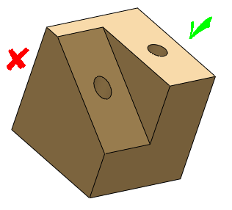

1. Holes intersecting cavities

Drilled holes should not intersect cavities. During machining, drills follow the path of least resistance when intersecting a cavity. The drill might wander when it reenters the material. If a hole must intersect a cavity, the drill axis should be outside the cavity.

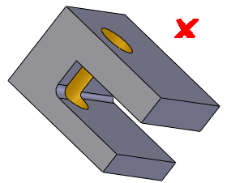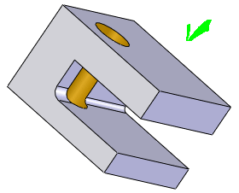

1. Partial holes

When a hole intersects a feature edge, at least 75% of the hole area should be within the material. Do not let the axis of the hole intersect an edge of the part or the drill will wander.

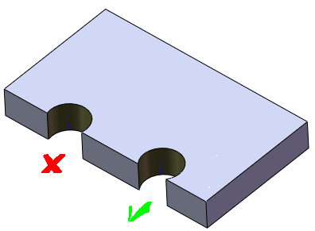

1. Linear and angular tolerances

Tolerances should be no tighter than necessary. Stringent tolerances might require special process parameters that are not within the natural capability of available machine tools.

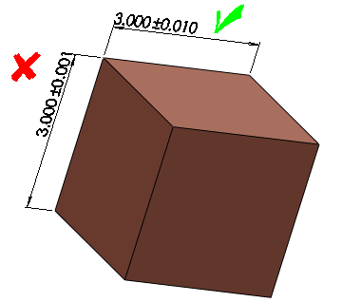

1. Standard Hole Sizes

Use standard tool bit and punch sizes for holes. Unusual hole diameters increase the cost of manufacturing.

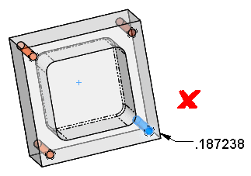

**Mill Rules**

1. Deep pockets and slots

Deep, narrow slots are difficult to machine. The long, slender end mills required to machine them are prone to chatter, which makes tighter tolerances difficult to achieve. Deep slots also make chip removal more difficult if the slot is blind.

Recommendations:

Avoid long corners with long radii.

Design milled areas so that the end mill length-to-diameter ratio is no greater than 3:1.

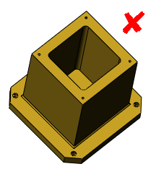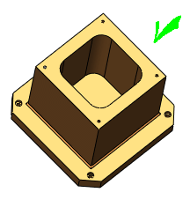

1. Inaccessible features

Features should be easily accessible for machining in the required direction. Inaccessible features require special cutters or machining techniques.

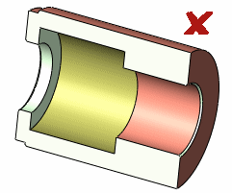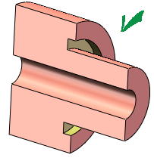

1. Sharp internal corners

Sharp inside corners cannot be achieved with traditional milling and require nontraditional machining processes such as electrical discharge machining (EDM).

Recommendations:

When designing a three-edge inside corner, one of the inside edges must have the radius of the end mill. A generous corner radius can accommodate a larger milling cutter, which is preferred. Use the radii recommended by fabrication personnel to ensure that tools are easily obtained and maintained.

If sharp corners cannot be avoided, drill a separate relief hole to allow a male ninety-degree corner to fit. Drill the hole first because drills cannot withstand significant side loading.

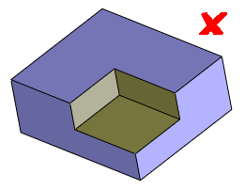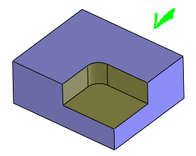

1. Fillets on outside edges

For outside corners, chamfers are preferred to fillets. An outside fillet requires a form-relieved cutter and a precise setup, both of which are expensive. Blending of fillets into existing surfaces is expensive to manufacture, even with ball end mill.

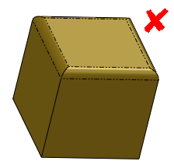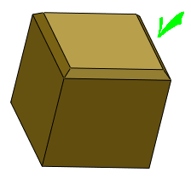

**Turn Rules**

1. Minimum Corner Radii for Turned Parts

Avoid sharp inside corners. Provide a generous inside radius to accommodate a tool with a large nose radius, which is less prone to breakage.

A turn-down surface perpendicular to an unmachined (cast) surface might cause burrs.

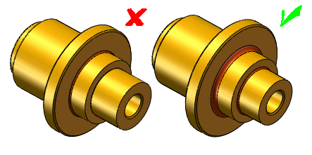

1. Bore Relief for Turned Parts

Provide tool relief for the bottoms of blind bored holes.

